OH 2 Documentation of the Back -end

Description du projet

The objective of this programme is to manage, in the simplest way possible, the administrative operations of the hospital, such as patient registration and laboratory analyses, and to produce statistics for the Ministry of Health. In the following chapters, users will find all the information they need to understand the structure of the backend. The picture below show the overall structure of the backend.

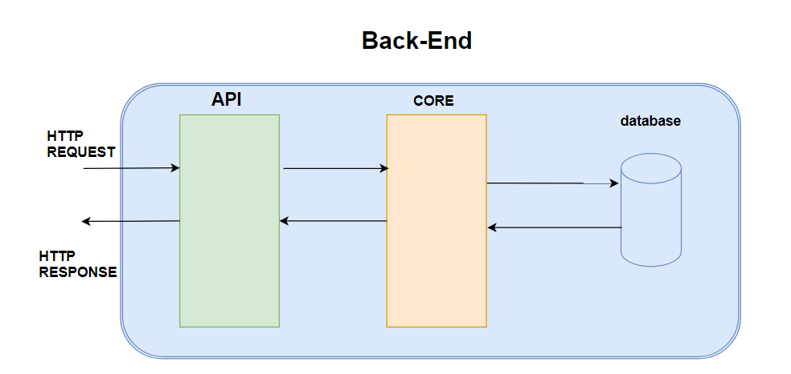

- Applications Programmings Interfaces (API)

The projet API name openhospital-api is the part of the Backend responsible for receiving HTTP request and contact the core to get or sent data, also returning HTTP requests when necessary. It is made With the spring boot framework and use Java language. This projet is organised in packages as shown in the following picture. We have three type of package (dto, mapper and rest) for every feature like accounting, admission, agetype, ….etc.

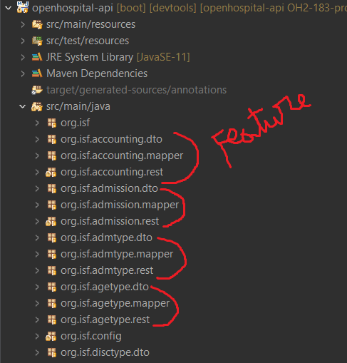
The dto package contains the classes that represent the data model(s) that transit between the front-end and the back-end.

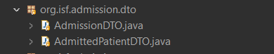

The mapper package contains the classe which have methods of converting a dto to an entity and an entity to a dto.

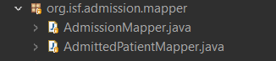

The rest package conatins the classe which have all the end point available for one feature.

- Core

The core of the project, called openhospital-core, is the business part responsible for processing the data and saving or retrieving it in the database. This project acts as an intermediary between API and the database. Like the API, It is made With the spring boot framework and also use Java language, each feature has three packages (Manager, Model and Repository). The figure below shows the organisation of the core project.

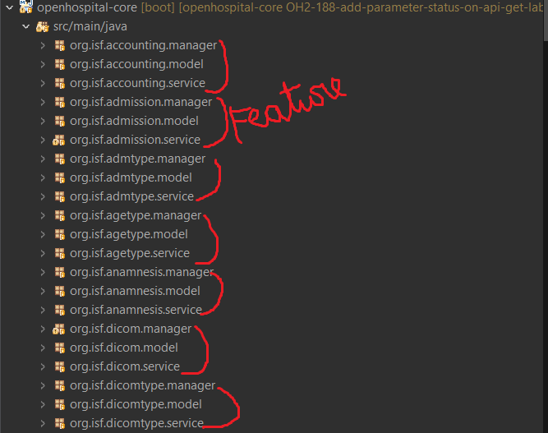

The manager package contains the classes that will perform processing on the data before contacting a method of the service package class.

The model package contains the classes that represent the data models that are present in the database.

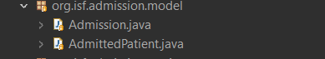

The service package contains the classes with all the methods that interact with the database

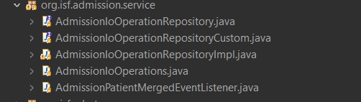

- The database (DB)

The database running in OpenHospital is made of three functional elements:
• the login DB: manages the access to OpenHospital (III.1) ;
• the main DB: links the main entities, such as patient, medicals, wards, exams, operations, etc. (III.2) ;
• the rest of the database: a series of independent tables for the secondary functions (III.3).

III.1 The Login DB

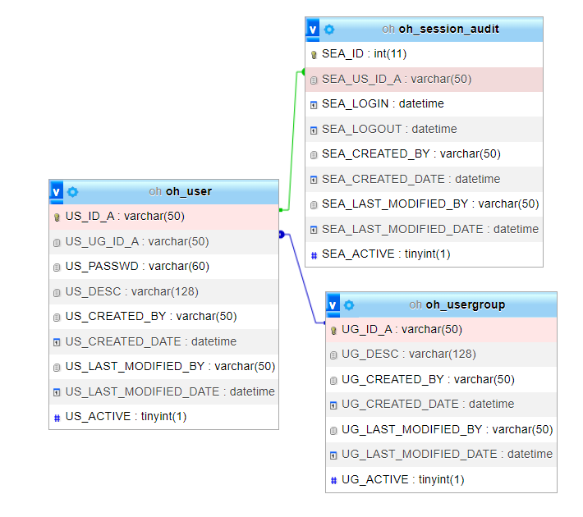

III.2 The main Database

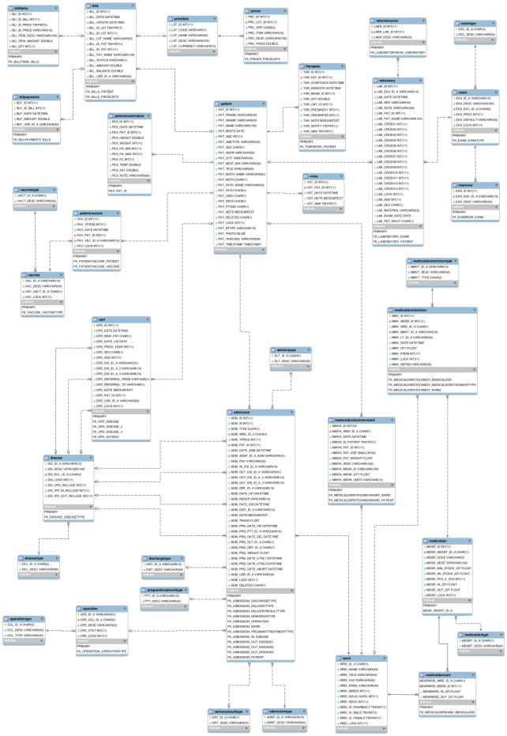

III..3 Other table on Database

